**Assignment-9**

# 🔧 Deploy a Project from GitHub to EC2

📝 **Objective**

Deploy a Node.js project from a GitHub repository to an Ubuntu EC2 instance using Bitvise SSH.

# ✅ Step 1: Launch an EC2 Instance

## Open EC2 Console

* + Go to <https://console.aws.amazon.com/ec2/>

## Click Instances (Running) > Launch Instance

**(launching AWS Console -> EC2)**

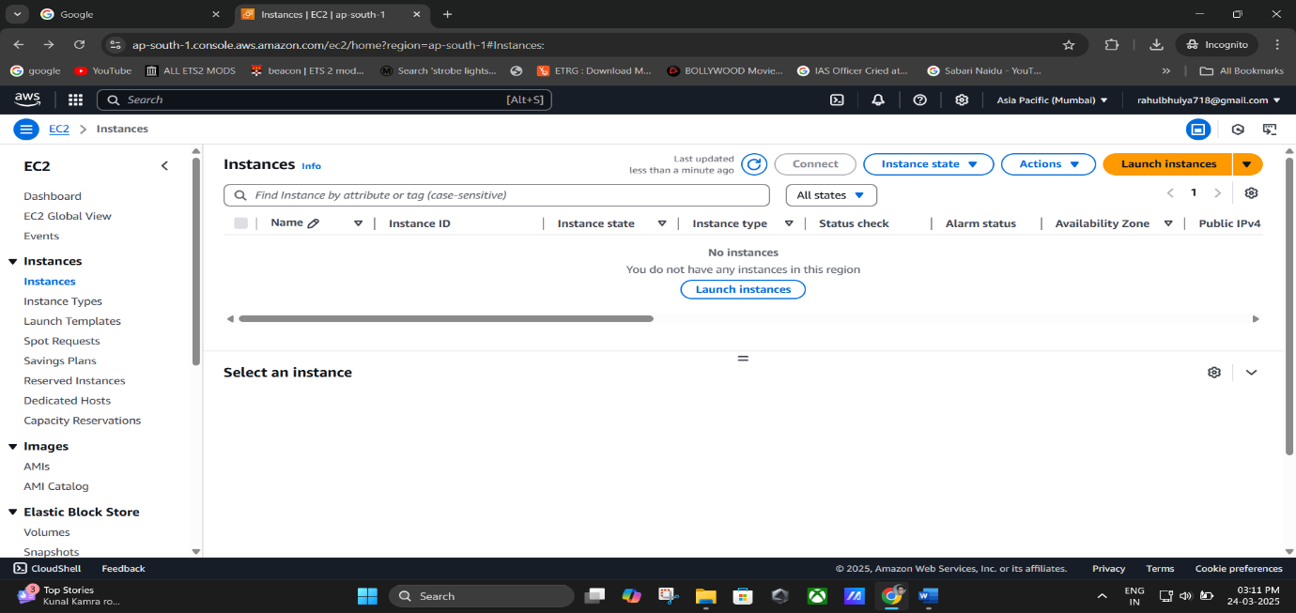

**(Click On “Instances”)**

**(Click On “Launch Instances”)**

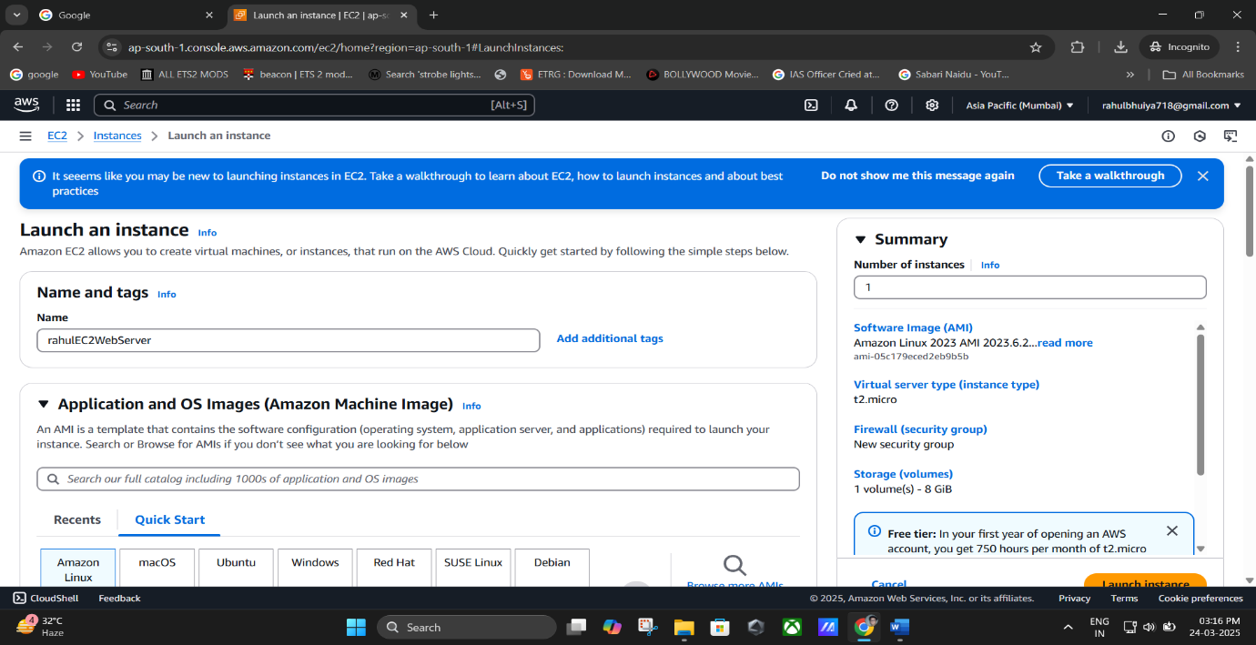

1. **Configure Instance**
   * **Name**: (e.g., rahulEC2WebServer)

## Application and OS Image:

* + - Choose **Ubuntu** under **Quick Start** (Free Tier eligible)
  + **Instance Type**: t2.micro (default, Free Tier)

## Key Pair (Login):

* + - Click **Create new key pair**
    - Name it (e.g., rahul1234)
    - Type: RSA, File format: .pem
    - Save the .pem file securely (you’ll need it to connect)

## Network Settings:

* + - Under **Firewall (Security Groups)**, check:
      * ✅ Allow SSH
      * ✅ Allow HTTP
      * ✅ Allow HTTPS

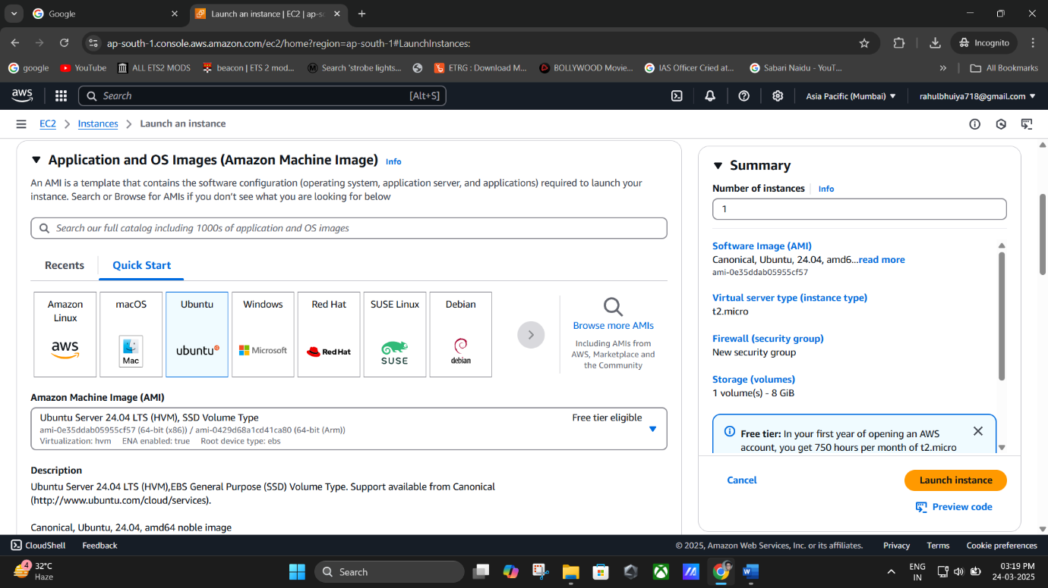

**Choose Ubuntu under Quick Start (Free Tier eligible)**

(Key Pair (Login) -> Type: RSA, File format: .pem -> Save the .pem file)

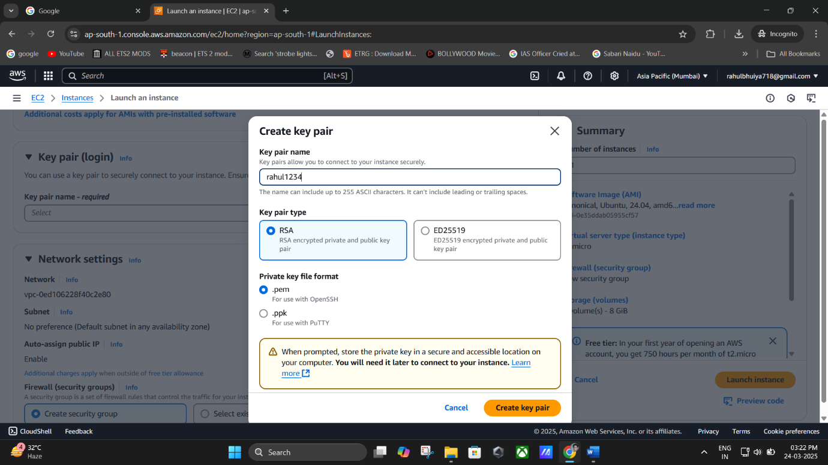

(Creating “**New Key Pair**”)

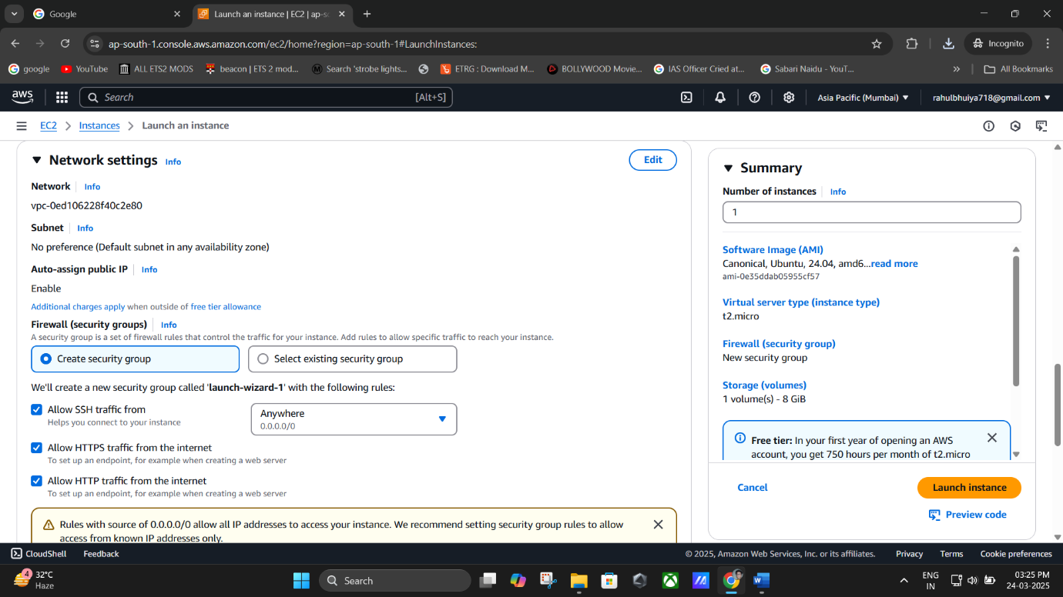

**(Network Settings -> Allow all SSH, HTTPS, HTTP)**

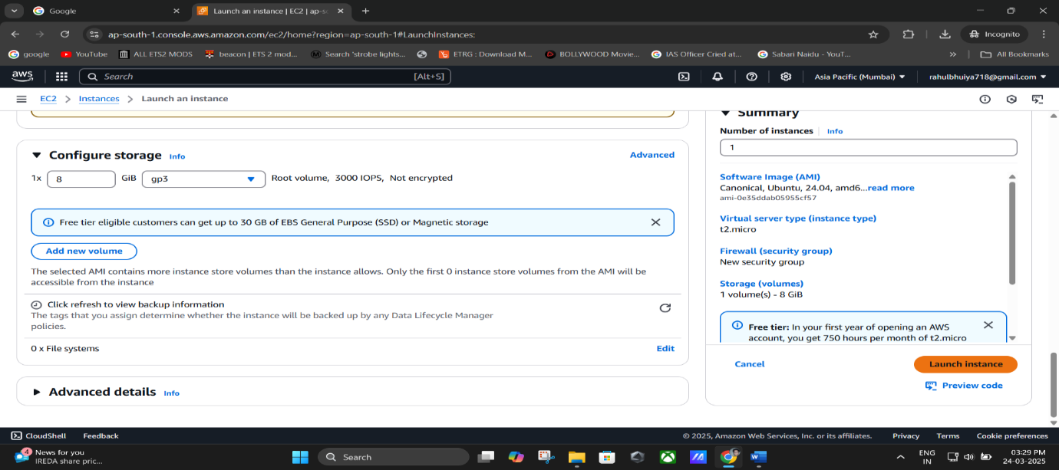

**(Click on “Launch Instance”)**

## Launch the Instance

* + Click **Launch Instance**
  + Click **View all instances** to go back to dashboard.

**(Main Instance Dashboard)**

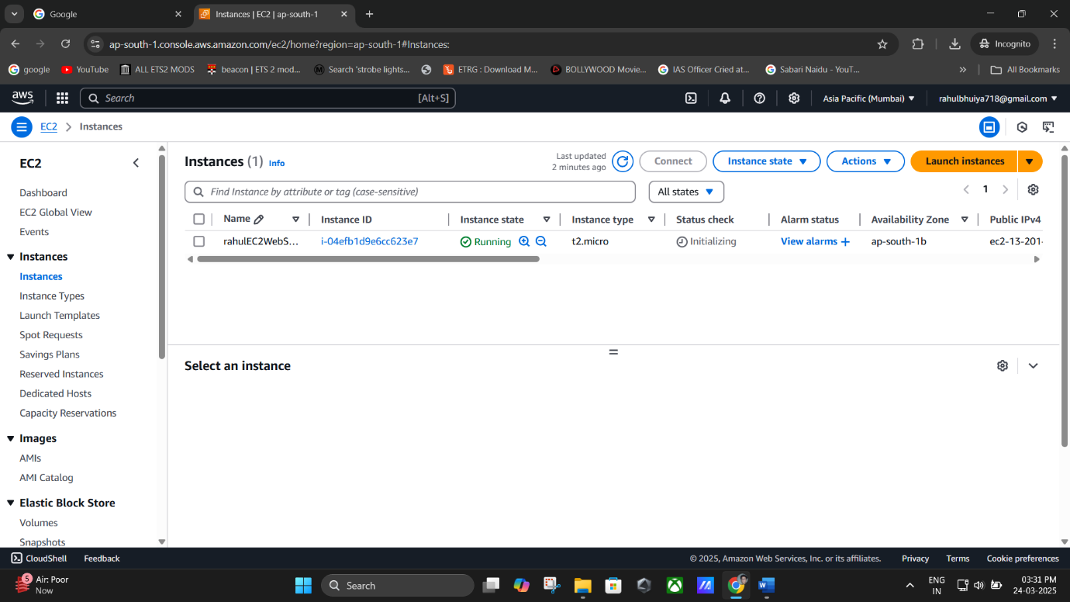

# 🔌 Step 2: Connect to EC2 via Bitvise SSH Client

## Get Public IPv4

* + Click your instance’s **Instance ID**
  + 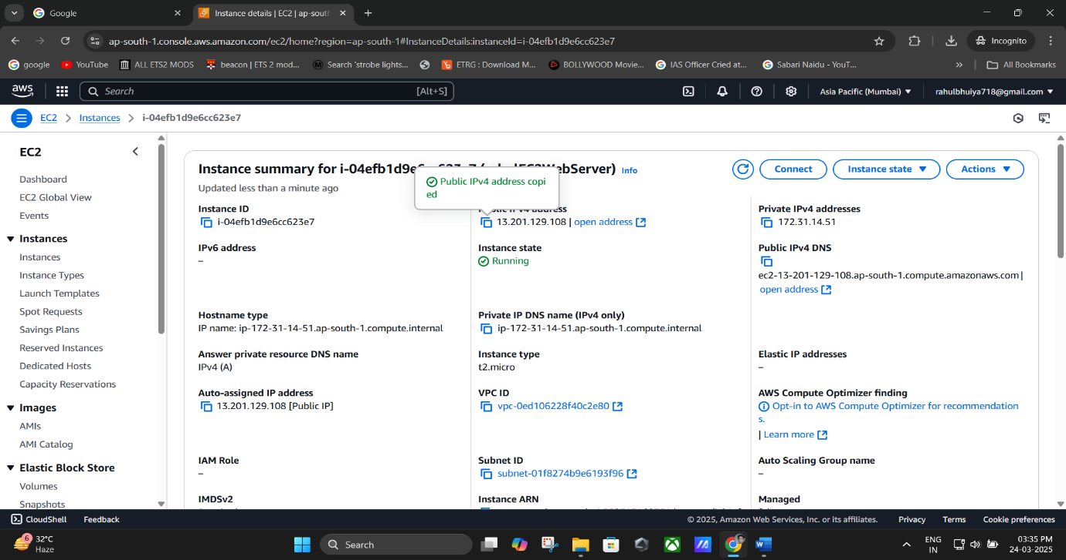Copy the **Public IPv4 Address**

(Copying the “**Public IPv4 address**”)

## Open Bitvise SSH Client

* + Download: <https://www.bitvise.com/ssh-client-download>
  + Open Bitvise and do the following:
    - **Server - Host**: Paste EC2’s Public IPv4
    - **Username**: ubuntu
    - Click **Client Key Manager**
      * Click **Import** and load your .pem file
      * It will appear as **Global 1**

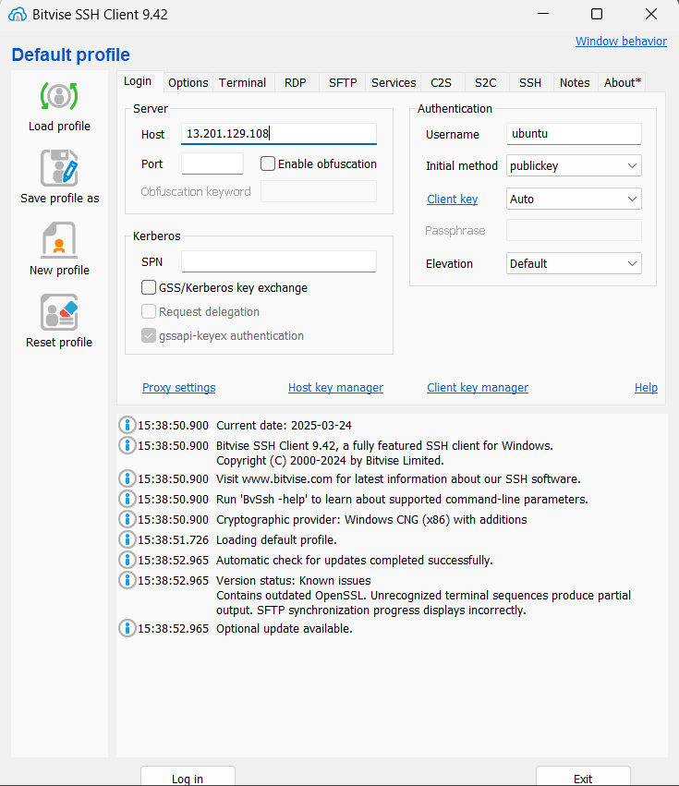

**(Paste the Public IPv4 address -> Host -> ubuntu)**

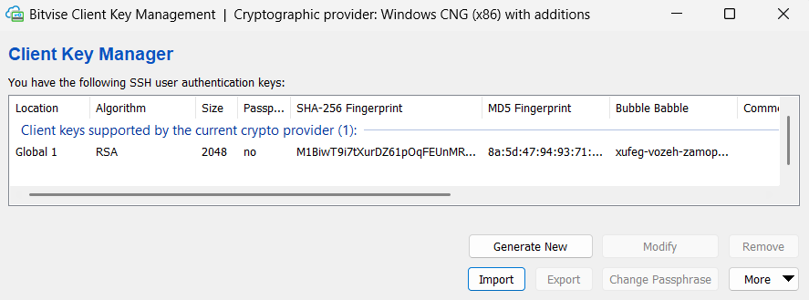

(**Client Key Manager ->** Click **Import** and load your .pem ->file **Global 1**)

* + - Set:
      * **Initial Method**: publickey
      * **Client Key**: Global 1
  + 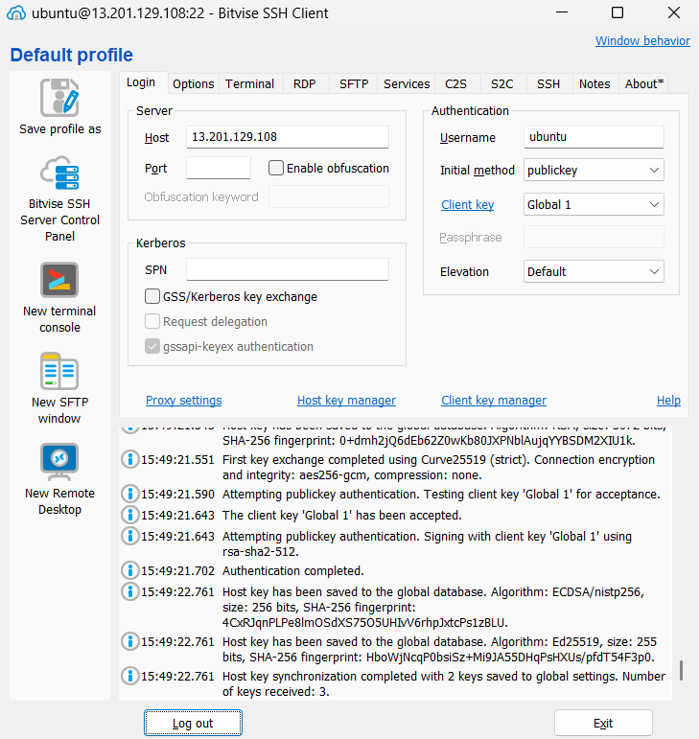Click **Log in** → Accept & Save

(**Initial Method**: publickey -> **Client Key**: Global 1 -> Click **Log in** → Accept & Save)

# 🖥️ Step 3: Set Up Server Environment in Terminal

Once inside Bitvise terminal:

## Update Packages

*sudo apt-get update && sudo apt-get upgrade*

Type y when prompted.

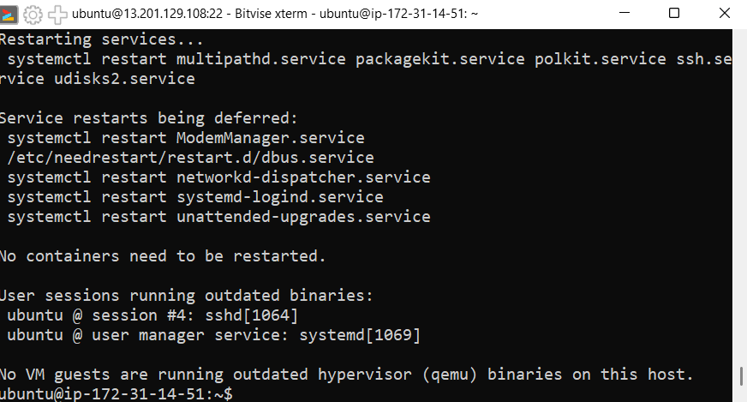

## Install NGINX

*sudo apt-get install nginx*

Type y when prompted.

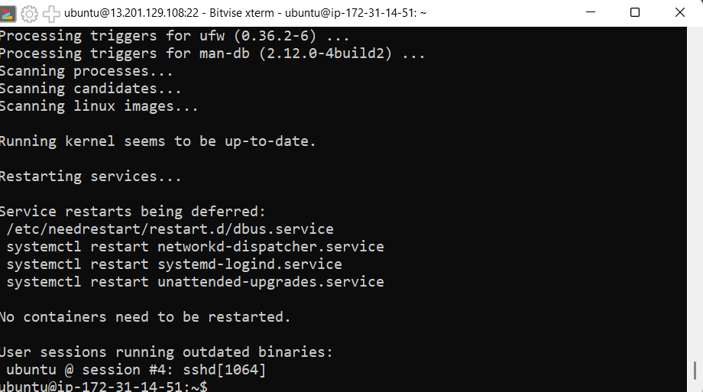

## Install Node.js

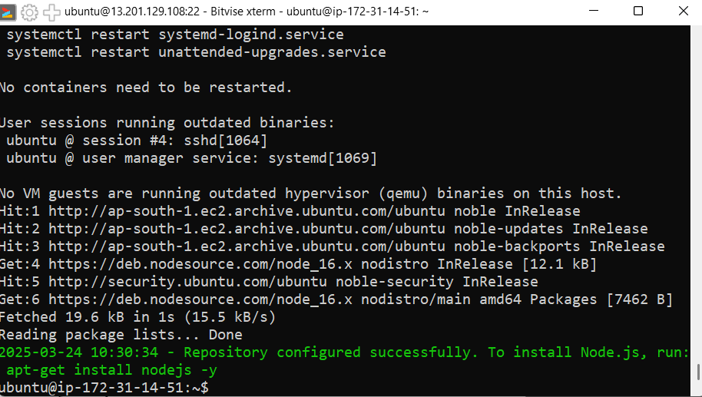*curl -sL https://deb.nodesource.com/setup_16.x | sudo -E bash - sudo apt install nodejs*

**(*curl -sL https://deb.nodesource.com/setup_16.x | sudo -E bash -*)**

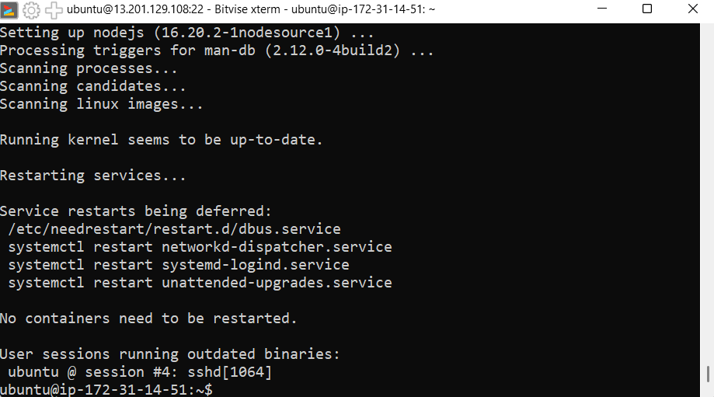

**(*sudo apt install nodejs*)**

## Clone GitHub Repo

*git clone https://github.com/RBhuiya/MCKV_AWS-Lab-.git*

* + When prompted:
    - **Username**: GitHub email
    - **Password**: GitHub token (not your password)

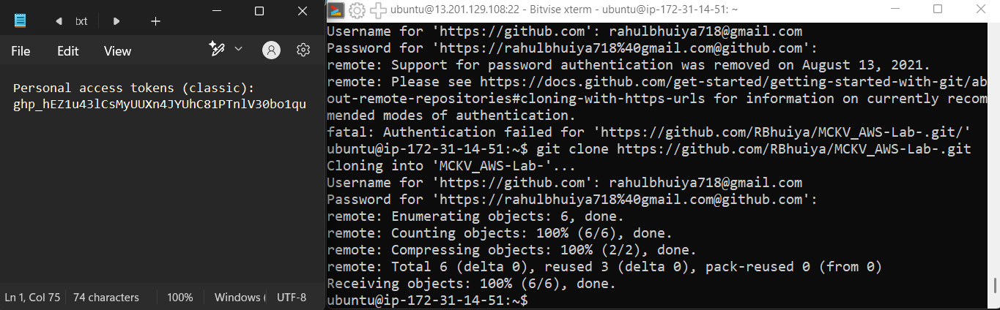

(**Username**: GitHub email -> **Password Paste your GitHub “Public access token (Classic)”**)

## Go to Project Directory

*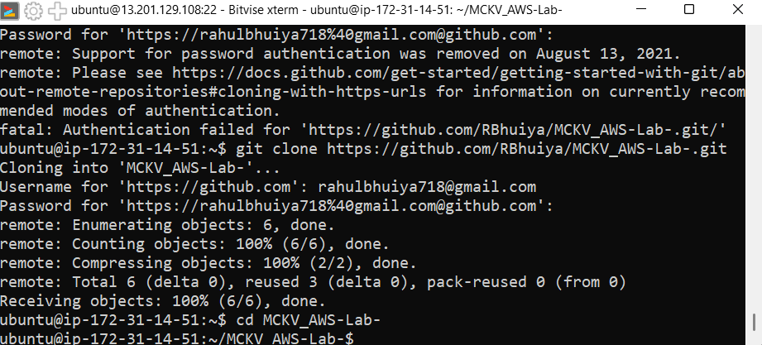cd MCKV_AWS-Lab-*

## Install Project Dependencies

*npm install*

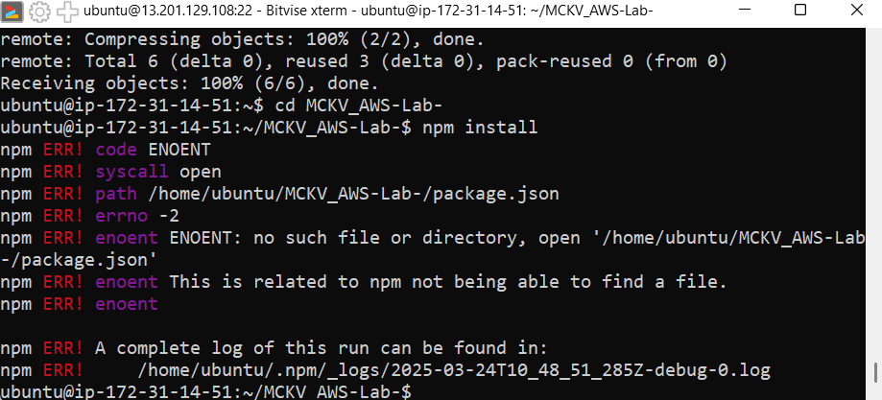

# 🌐 Step 4: Allow App Port (e.g., 4000) in Security Group

1. Go to **EC2 Dashboard**
2. Click your **Instance ID**

## Go to **Security > Security Groups**

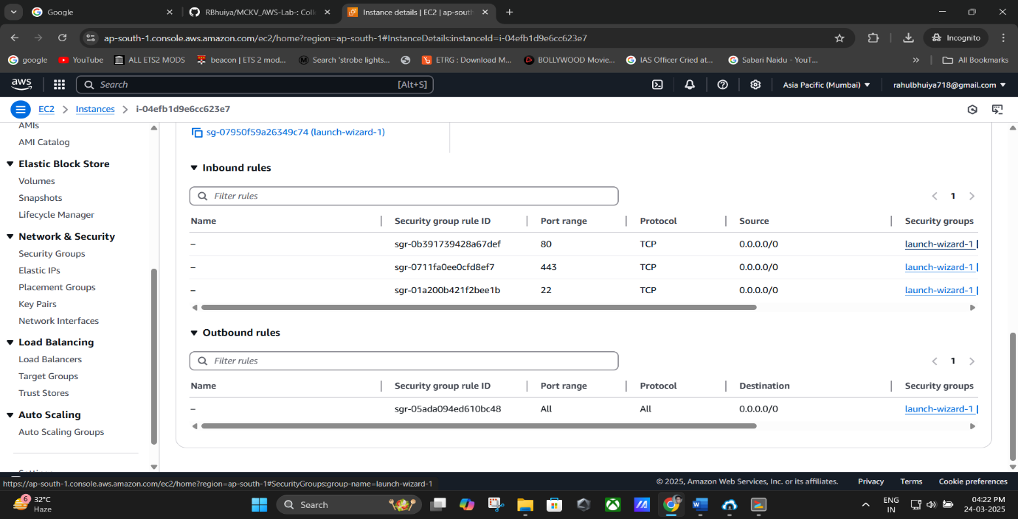

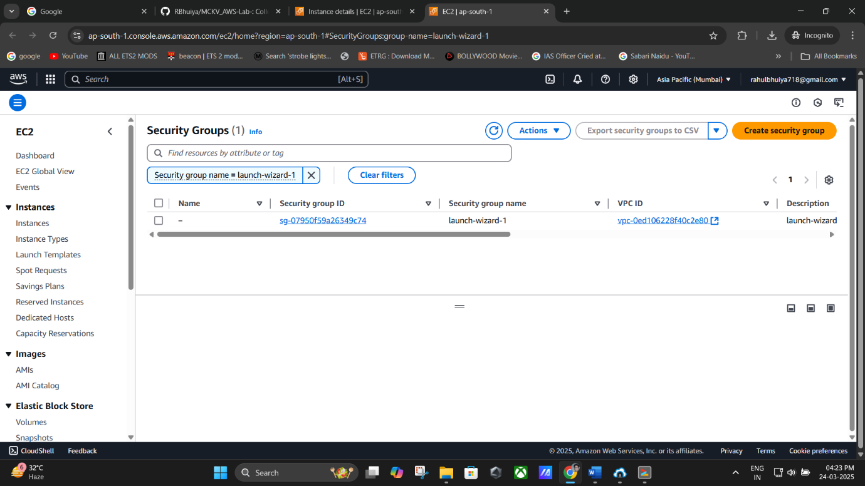

**(Security Group)**

1. Click **Edit Inbound Rules**
   * Click **Add Rule**
     + **Type**: Custom TCP
     + **Port Range**: 4000
     + **Source**: Anywhere (0.0.0.0/0)

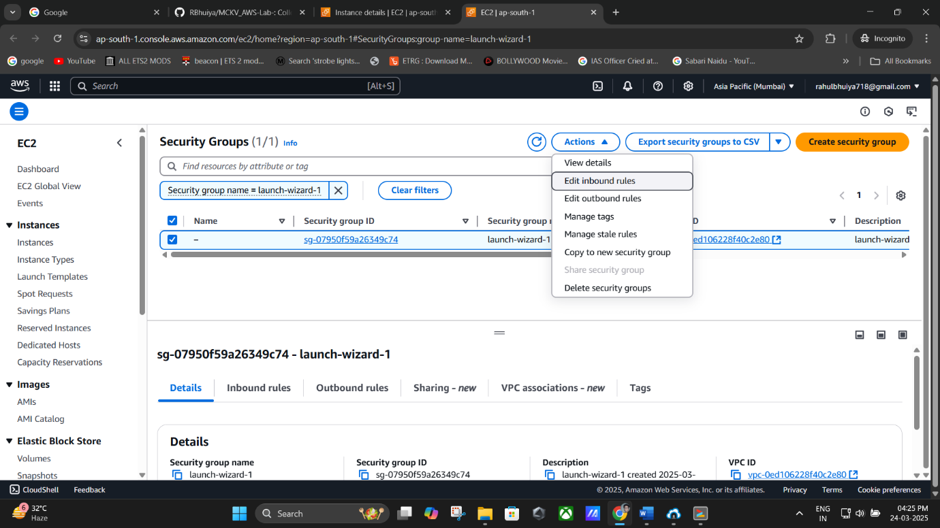

(Click on “**Edit Inbound Rules**”)

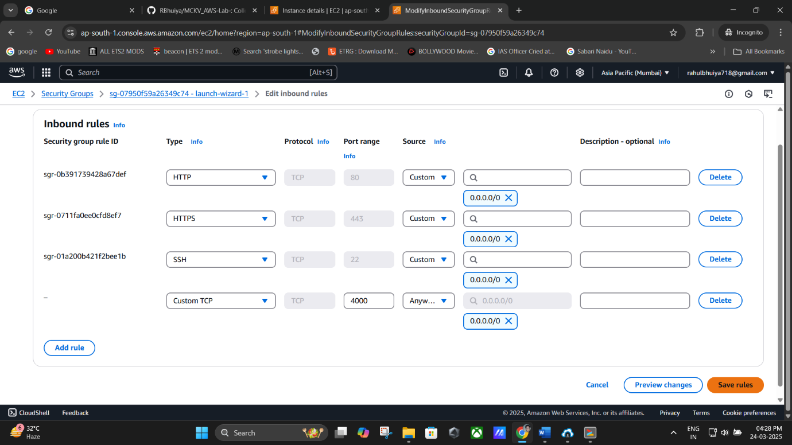

(Editing The **Port Range:** 4000 and **Source:** Anywhere (0.0.0.0/0))

1. Click **Save Rules**

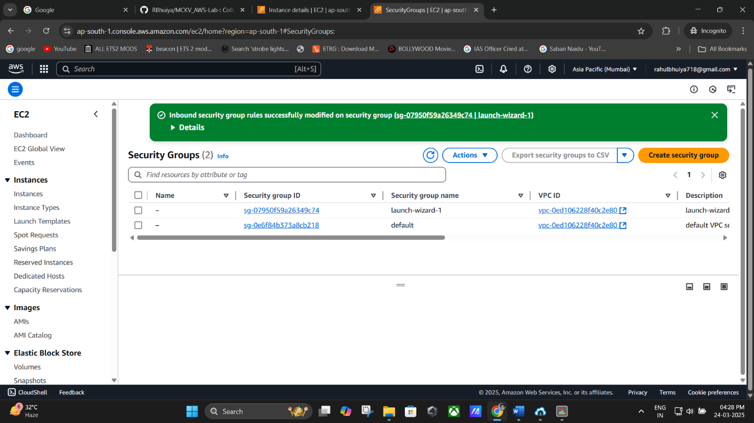

**(Click Save Rules)**

# 🚀 Step 5: Run the Node.js App

In Bitvise terminal:

*node index.js*

* If no error appears, the server has started.
* Open your browser and enter: http://<your-ec2-public-ip>:4000 E.g., [http://3.91.123.45:4000](http://3.91.123.45:4000/)

You should now see the deployed application running from the GitHub repo.

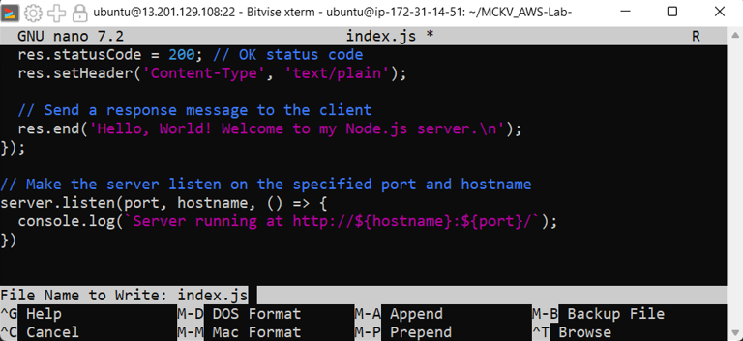

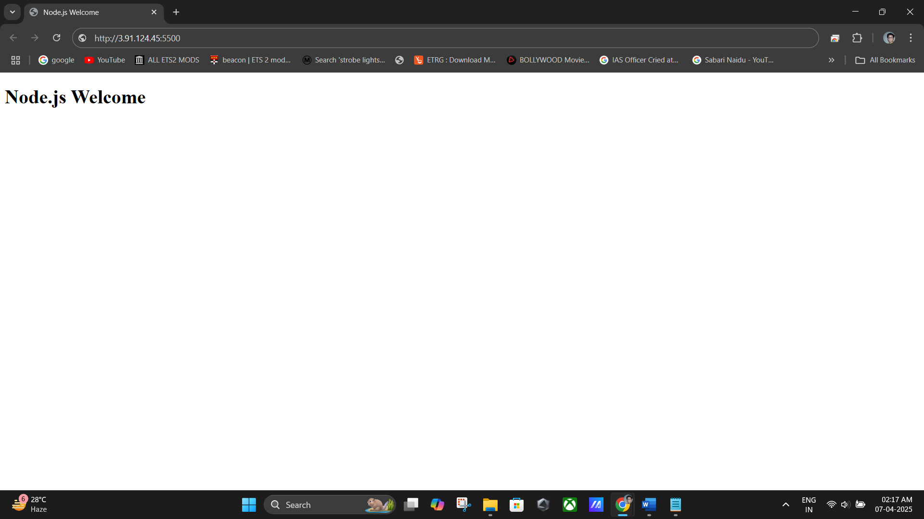

# 📌 Summary of Commands

*sudo apt-get update && sudo apt-get upgrade sudo apt-get install nginx*

*curl -sL https://deb.nodesource.com/setup_16.x | sudo -E bash - sudo apt install nodejs*

*git clone https://github.com/RBhuiya/MCKV_AWS-Lab-.git*

*cd MCKV_AWS-Lab-*

*npm install node index.js*